This document is merely to point out the differences in confessional count numbers between my findings and the official numbers posted on Survivor Sucks. The guidelines I use can be found [here](https://docs.google.com/document/d/18ofsPiVWxSejzSjEGlU8KEx4Og2ddEJScCV23RsCPIA/edit?usp=sharing).

**Survivor Sucks Season 30 Counts** ([link](https://goo.gl/photos/dFfUMTYRMhXpKY8u5))

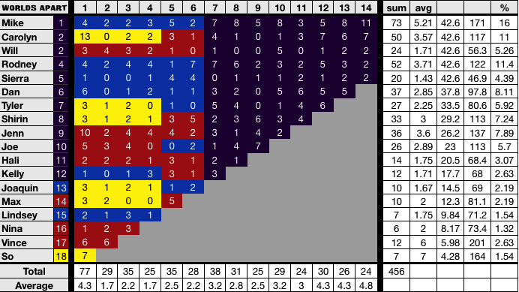

**My Season 30 Counts** ([link](https://goo.gl/photos/fWzZj5w9gECuGfXs6))

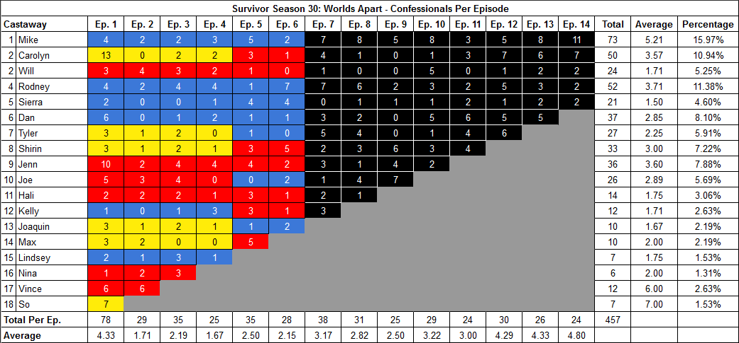

[Survivor Sucks Season 30 thread](http://survivorsucks.com/topic/118876).

**Differences**

[Episode 01](https://docs.google.com/document/d/1hL6DEAa5zVgXYpTIlZT0O8cL5eyhhkIHvLLNNEm2p_Q/edit?usp=sharing)

* **Sierra: 2 (+1)** Confessional #13 is a Sierra intro voice over right before Probst says his signature “39 Days, 19 People, 1 Survivor!” I counted this.

**No Change**

* [Episode 02](https://docs.google.com/document/d/1VH9MihtWyeCDYpoVdb7Aa2FbWdEQpQ9V80nFjmfO4WE/edit?usp=sharing)
* [Episode 03](https://docs.google.com/document/d/1CUPg0TfK0lsWwK5i96l4HMKEsNwF_XDuU3LLUtMMD5A/edit?usp=sharing)
* [Episode 04](https://docs.google.com/document/d/1LpQ4dj6OGonLplLo4c6Y5PPg9B2vy5hEGg27CTm7vfI/edit?usp=sharing)
* [Episode 05](https://docs.google.com/document/d/1A2ArBKzf4f0T4mgWFqc8RlX2i-BlZKKQNUGfdPumDUc/edit?usp=sharing)
* [Episode 06](https://docs.google.com/document/d/1Y7gKOPi9f5vJb7wcE28LHT2EMt3KwvYti78QO094nVg/edit?usp=sharing)
* [Episode 07](https://docs.google.com/document/d/1VaE3F97a5blz6UqnjiRm217HxxupuxRinAhYURlJz9c/edit?usp=sharing)
* [Episode 08](https://docs.google.com/document/d/1rjmF29W2nvm2HQabrNdwXTfRrEFvrwZE3wHbhYEO80s/edit?usp=sharing)
* [Episode 09](https://docs.google.com/document/d/1HPky1yFN3qbT-IxIKcrYo1qtIRTm8JTVll02m0Fg0Sk/edit?usp=sharing)
* [Episode 10](https://docs.google.com/document/d/1oSJQ9bAtzNhRPx3ykPcNRXTDd_1FYypo-G07RhG3t_Q/edit?usp=sharing)
* [Episode 11](https://docs.google.com/document/d/16lYom6KCeYyiK9ssa7ONY_n1tFspXpWg7Emwv7Y5N1Y/edit?usp=sharing)
* [Episode 12](https://docs.google.com/document/d/1VlBMOfzpRzNew5wo56VsbqnSewLMYkaWqwvFRJnyeO4/edit?usp=sharing)
* [Episode 13](https://docs.google.com/document/d/1R40FCKEd2CdQT_j8Wl-IF5hSg9CnrGAtALWpLPMkz6Q/edit?usp=sharing)
* [Episode 14](https://docs.google.com/document/d/16mljORVJN0un--xDF5gurSYGarrgiH5p3G6rQiaK_q0/edit?usp=sharing)

|  |  |  |
| --- | --- | --- |
| **Castaway** | **Count** | **Change** |
| Sierra | 21 | (+1) |
| **Total** | **457** | **(+1)** |